Case Study 82 : Multi-Criteria Internship Candidate Ranking
1. Problem Statement
Evaluate internship candidates using academic marks, assessment scores, attendance and eligibility conditions. Rank qualified candidates and apply tie-breaking rules.
2. Objectives
Check minimum academic, assessment and attendance requirements.
Calculate a combined score for eligible candidates.
Rank candidates using combined score and assessment score.
3. Assumptions
Minimum CGPA is 7.0, assessment score is 60 out of 100 and attendance is 80%.
Combined score = 40% academic percentage + 50% assessment + 10% attendance.
Ties are resolved by higher assessment score, then candidate ID.
4. Algorithm
Read candidate details.
Check minimum eligibility conditions.
Calculate the combined score for eligible candidates.
Store eligible candidates.
Sort by combined score, assessment and candidate ID.
Display the ranked shortlist.
5. Flowchart
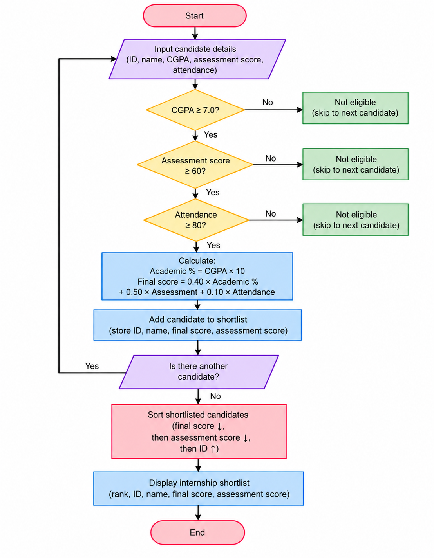
6. Pseudocode
START
Read candidate details.
Check minimum eligibility conditions.
Calculate the combined score for eligible candidates.
Store eligible candidates.
Sort by combined score, assessment and candidate ID.
Display the ranked shortlist.
Display result
STOP
7. Test Cases
Input / Record | Expected Result
P101 | Eligible; combined score 83.8
P103 | Rejected; CGPA below 7.0
P104 | Eligible
8. Output Screenshot
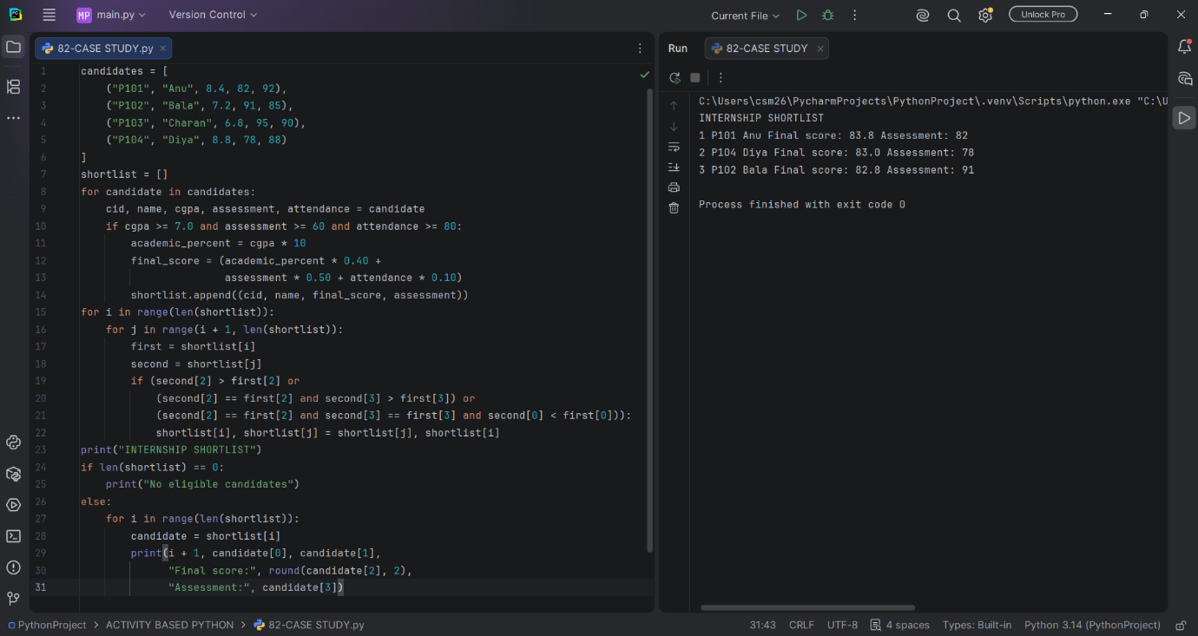
9. Conclusion
The program applies multiple eligibility criteria and produces a ranked internship shortlist.

